**Activity 5 – WORKING WITH COMMANDS**

**TASK 1: CREATE aliases**

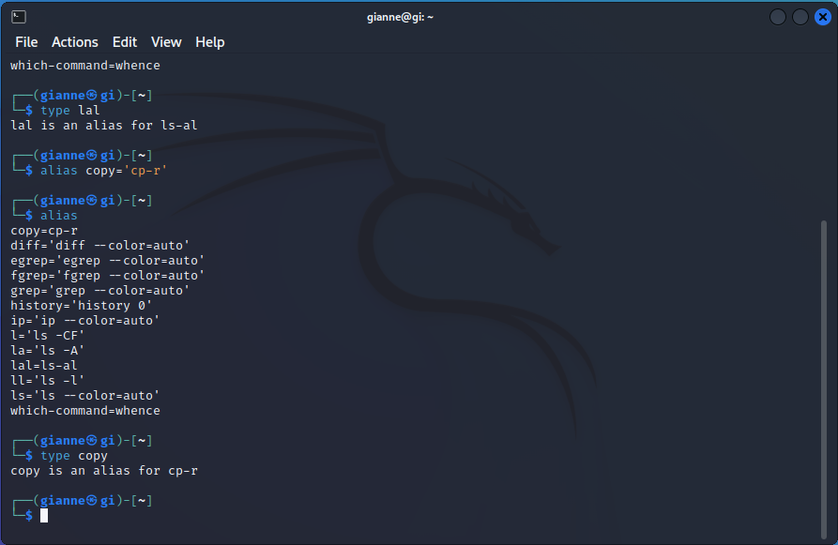

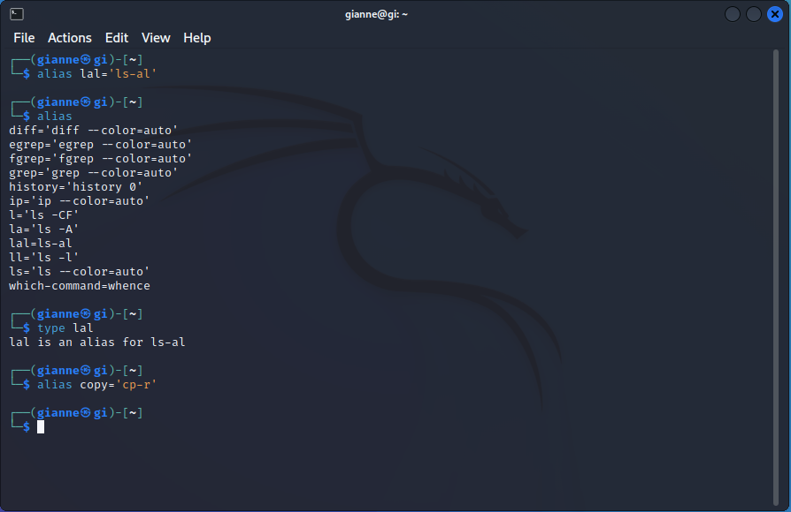

**TASK 2: USE man and help**

HOW DO YOU ACCESS THE MANUAL PAGE FOR THE “grep” COMMAND?

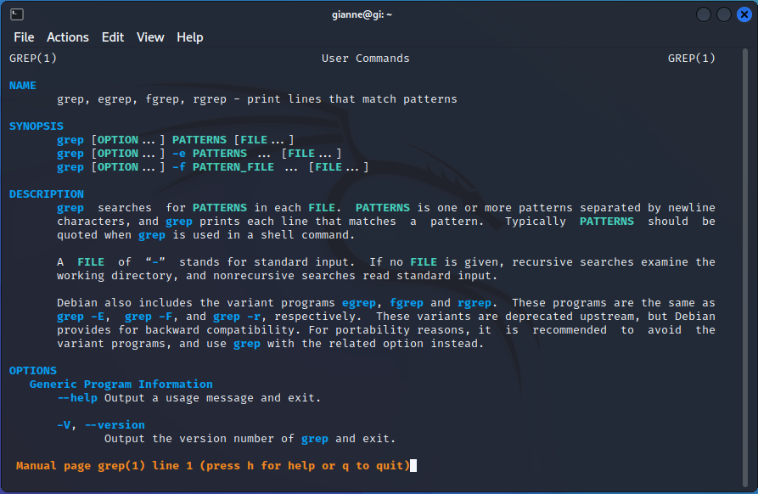

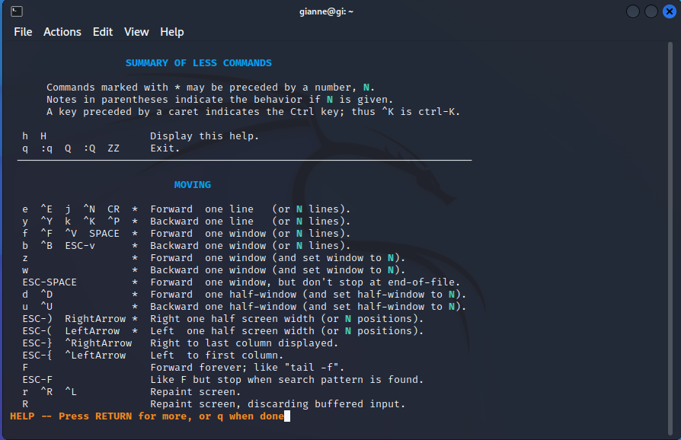

WHAT COMMAND CAN YOU USE TO FIND OUT MORE ABOUT A SHELL COMMAND?

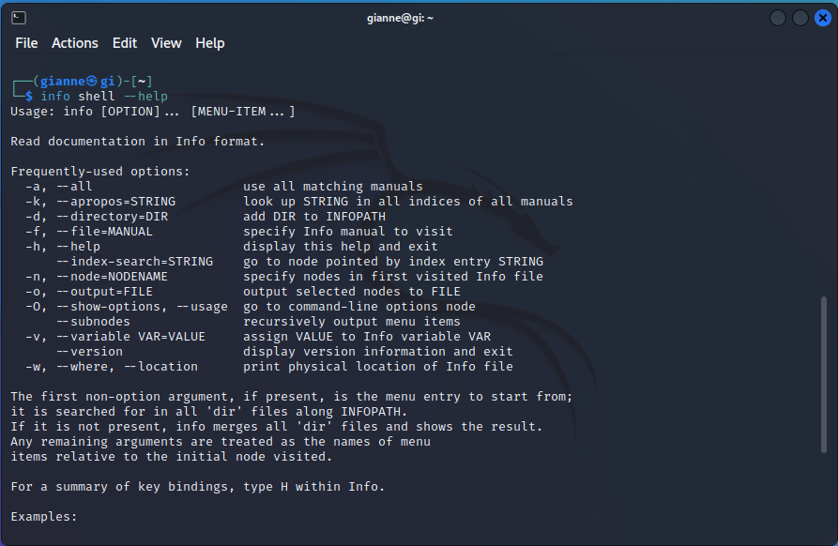

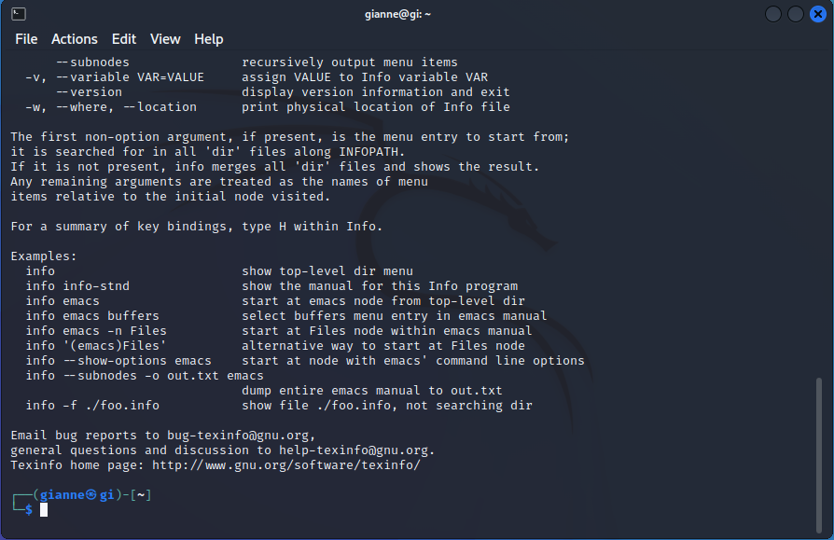

WHAT COMMAND CAN YOU USE TO LIST ALL AVAILABLE OPTIONS AND COMMANDS FOR THE “tar” COMMAND?

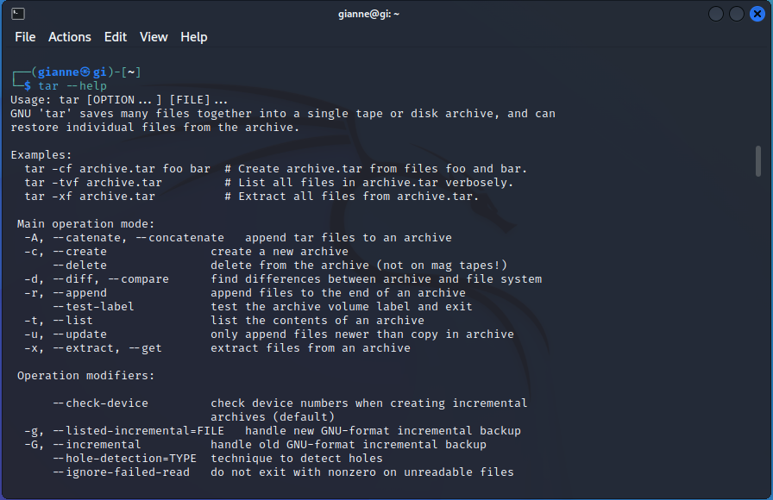

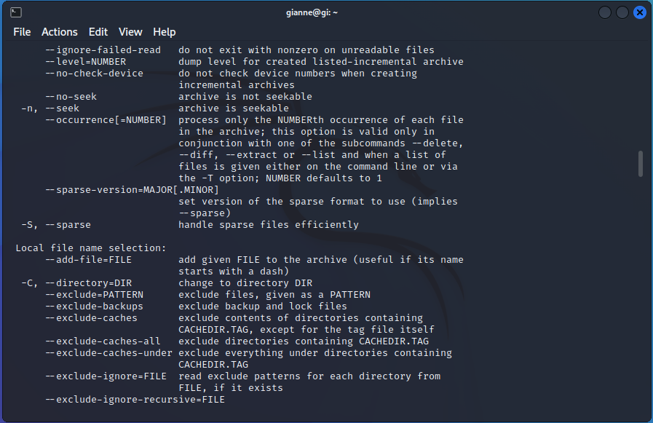

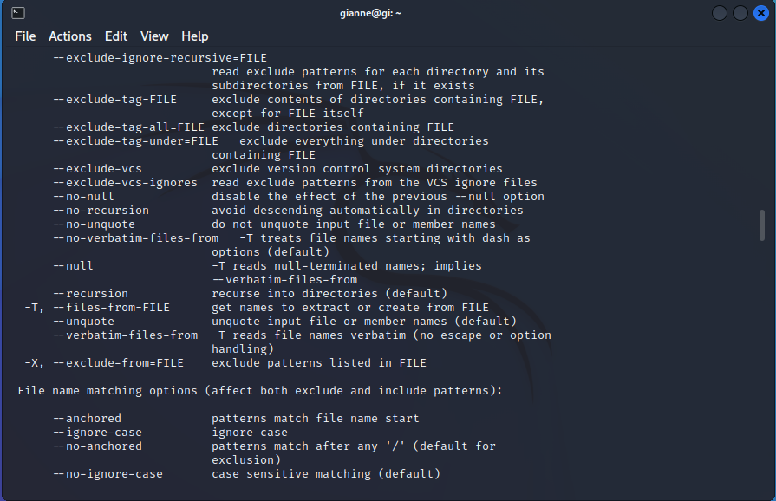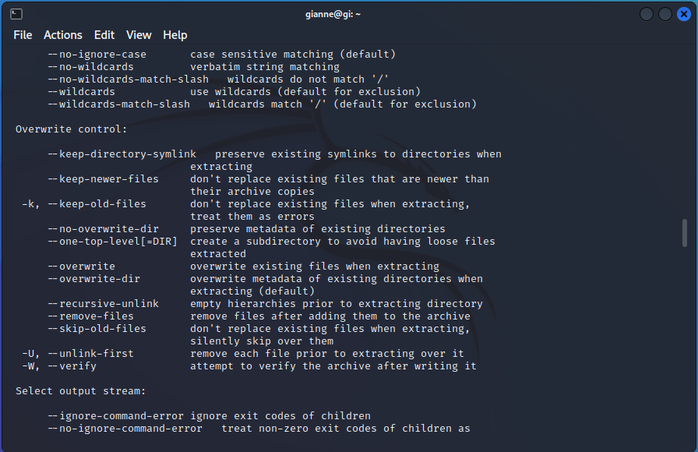

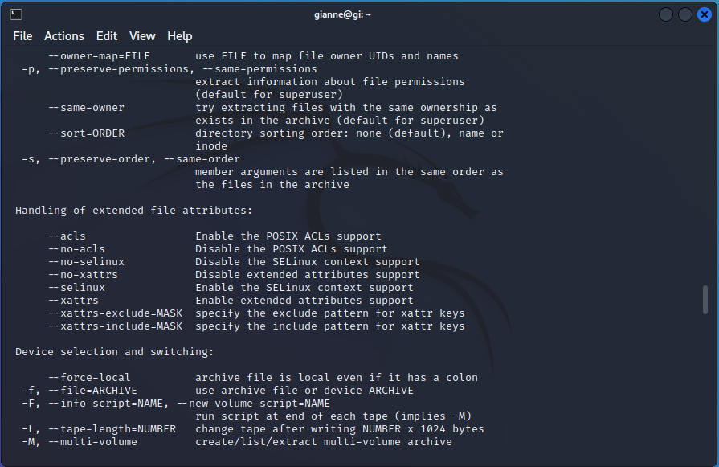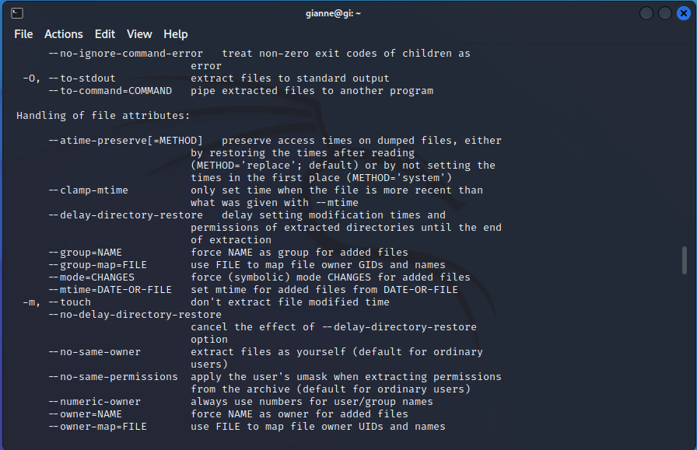

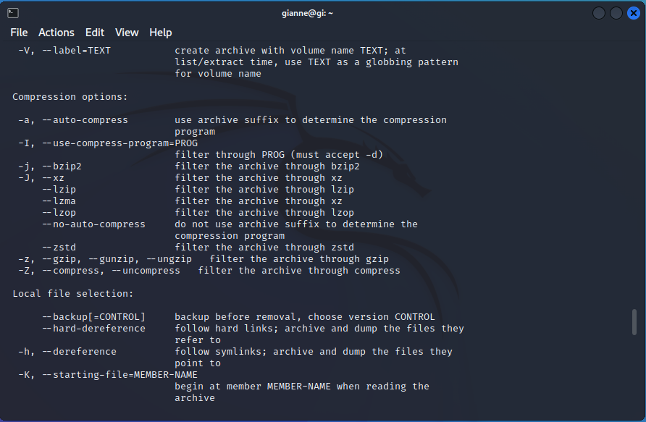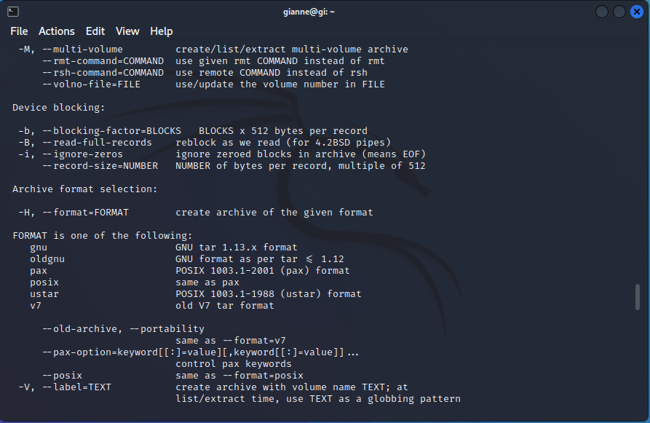

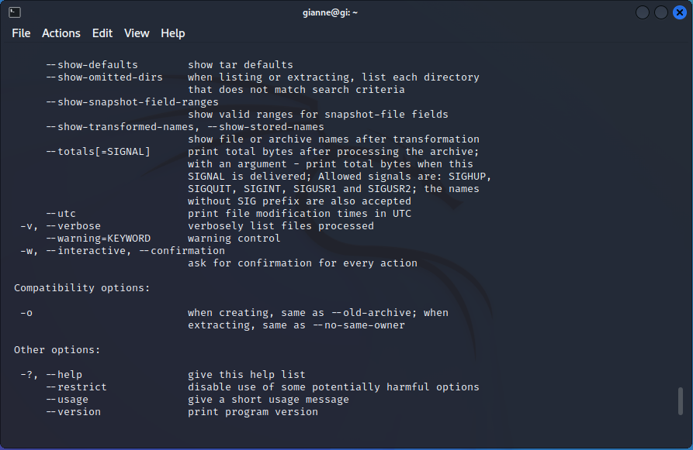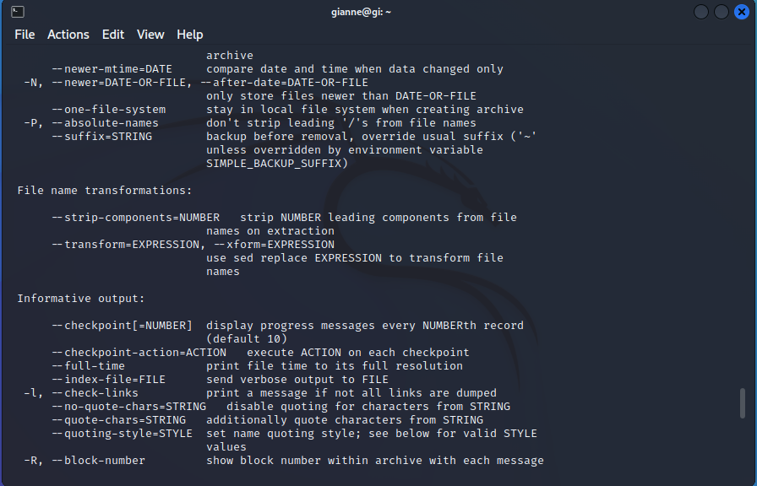

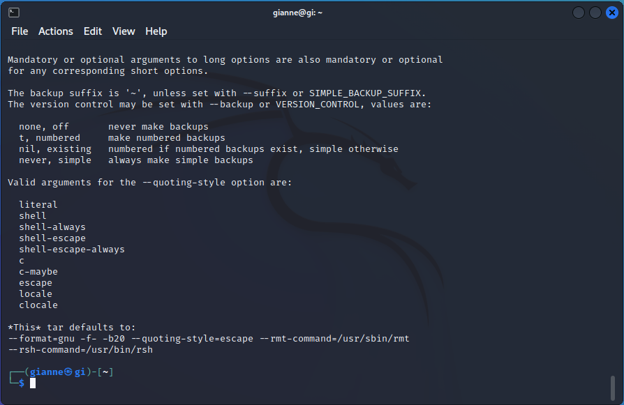

**TASK 3: USE info –help**

WHAT IS THE COMMAND TO ACCESS THE INFO DOCUMENTATION FOR THE “tar” COMMAND?

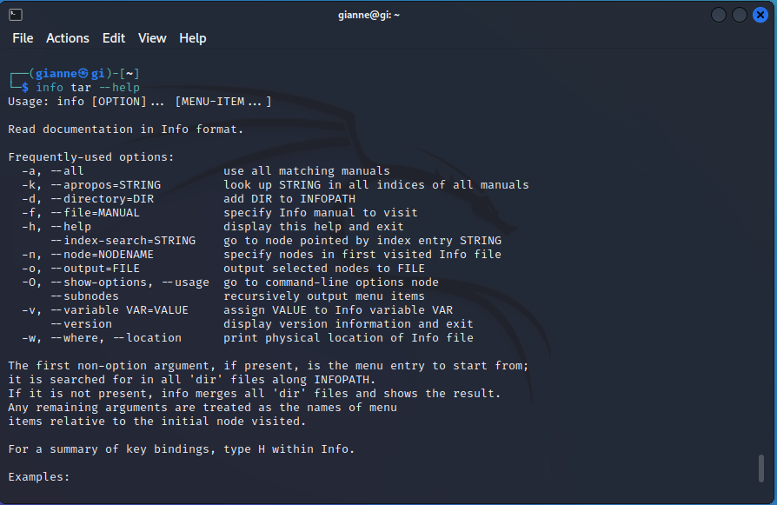



WHAT COMMAND CAN YOU USE TO SEE A LIST OF AVAILABLE INFO FILES?

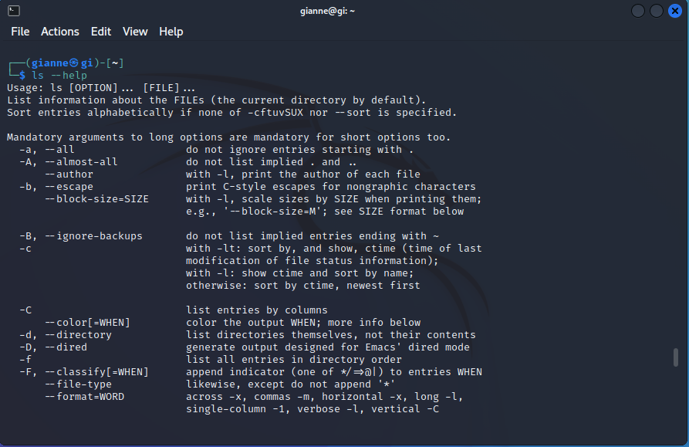

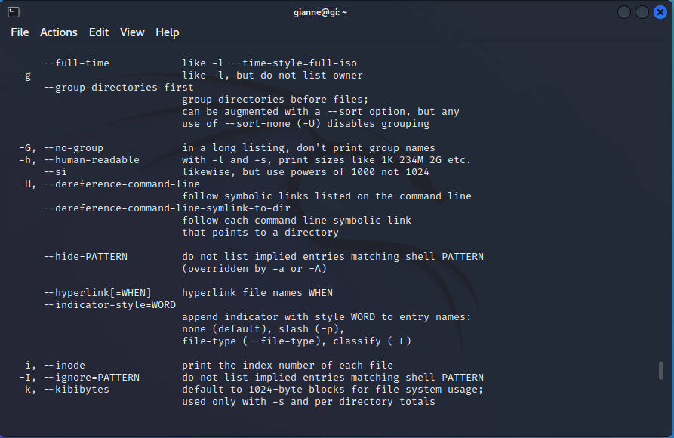

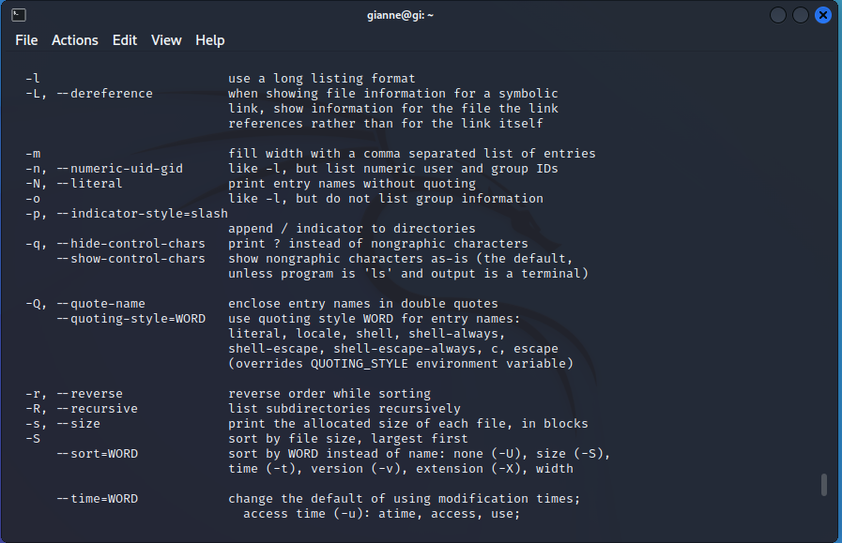

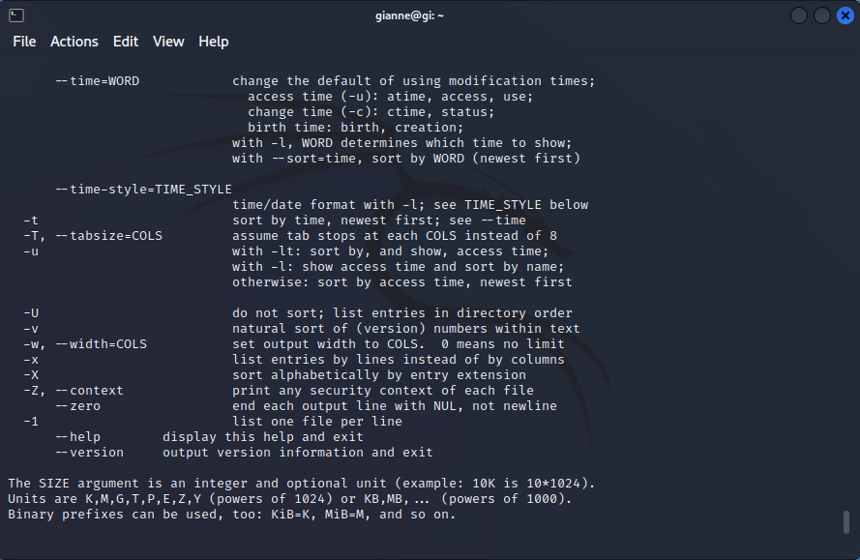

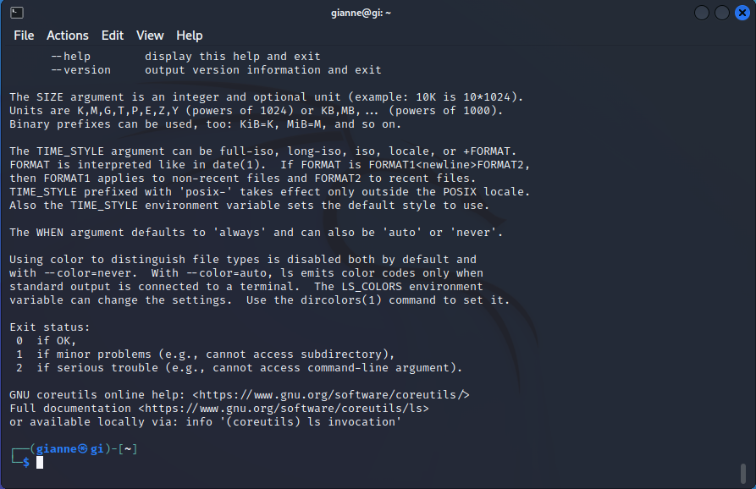

**TASK 4: CREATE AN ALIAS FOR A COMMAND OF YOUR CHOICE, AND PROVIDE A BRIEF EXPLANATION OF WHY YOU CHOOSE THAT COMMAND AND HOW THE ALIAS WILL MAKE IT EASIER TO USE.**

